THE BROKEN
CONCLAVE
COLLEGIUM ASSIGNMENT I:
THE FALLING SPAN
Expeditionary Disaster Response
Scenario A1 - DM Draft v1 - Level 4

Assignment I: The Falling Span
The Falling Span is the recommended first formal Collegium Assignment for a continuing Broken Conclave campaign. It is designed for 4th-level characters after the Feywild rendezvous and Perrin's offer of Collegium residency. The exercise introduces the academic competition system, class-specific demonstrations, rival-team standings, and the expectation that Collegium practicals use real initiative and real class resources.
SCENARIO PURPOSE
This first Assignment should end safely. Do not add a surprise combat, random encounter, or hidden second crisis after the practical. Part of the long-term design is to teach the players that they can spend spell slots and limited class features during formal Assignments. Later Scenarios can violate that expectation.

Scenario at a Glance
Element | Details
Level | 4
Expected Play | One session, roughly 3-4 hours including orientation, the Assignment, debrief, social play, and the first Collegium downtime window.
Course | Expeditionary Disaster Response I
Lead Instructor | Master Corvin Drae, Wizard 8 / Fighter 7
Initiative Limit | 8 rounds
Primary Objective | Rescue at least 5 of 6 civilian simulacra and deliver the sealed dispatch case to the East Extraction Platform before the end of round 8.
Individual Requirement | Every PC must complete one class-specific Demonstration Requirement before the team can pass.
Competition | At session start, every player secretly generates one rival-team result with 1d6. For this Assignment, add +3 to each recorded roll.
Narrative Tether | Introduces recurring rival teams, class mentors, Tavian as a fellow resident, Academic Standing, and the first formal downtime window. It intentionally contains no Caelan or Quiet Hand clue.
Advancement | Treat as one substantial initiative-based practical toward the campaign's eventual level advancement. It does not itself grant a level.

Scenario Flow
- Before any explanation, ask every player to roll 1d6. Record the results in seat order and say only that they will matter later.
- Dean Aveline Quorr completes the party's Independent Studies orientation and sends them to the Spanworks.
- Master Corvin Drae briefs the Falling Span practical and issues each PC a class-specific Demonstration Requirement.
- The party enters initiative and attempts the eight-round rescue while the bridge progressively fails and training harriers interfere.
- At completion or failure, Corvin debriefs the team. The DM reveals that the opening d6 rolls generated rival completion times.
- The scoreboard establishes the party's first Academic Standing marks. The session ends with campus social time and Downtime Window 1.

Before Play: The Unexplained Roll
OPENING PROCEDURE
Before the recap, before the Collegium description, and before telling the players what the Assignment is, ask each player to roll 1d6. Write the results down in player-seat order. Do not explain them. Each roll will later be attached to one rival team. For The Falling Span, rival completion round = d6 + 3. A result of 9 exceeds the eight-round limit and means that rival team failed.
At the end of this first Assignment, tell the players what the rolls represented. Do not promise that future Assignments use the same die or modifier.

Part 1: Independent Studies Orientation
The characters are not conventional degree candidates. Perrin has arranged for them to reside at the Collegium as Special Independent Studies Fellows: field-capable practitioners who attend group practicals with wizard students while receiving short individual instruction from the Collegium's multiclass specialists. Their class abilities remain normal D&D abilities; the curriculum provides the in-world explanation for practicing and refining them.
Morning bells roll across the Collegium in overlapping tones, answered by doors, footsteps, and the rising murmur of thousands of students moving between towers. The inner courts smell of rain on stone, lamp oil, ink, and breakfast bread. Animated notices drift beneath archways announcing lectures, club meetings, examination changes, and arguments disguised as academic symposia.
Dean Aveline Quorr waits beneath a covered arcade with a stack of slate cards tucked under one arm. The small gnome looks over the group, then toward a broad iron door marked EXPEDITIONARY PRACTICALS. 'You are not here to become wizards,' she says. 'Some of you have already made much more complicated mistakes. You are here to learn what you can do, what the people beside you can do, and how not to make either of those facts somebody else's problem.'
ROLEPLAYING DEAN AVELINE QUORR
Aveline is the Independent Studies coordinator. She is efficient, dryly kind, and allergic to unnecessary ceremony. She explains only what the players need now: every group practical has a team objective, and each Independent Studies Fellow also receives one individual demonstration from their mentor. No stress, grade-point, or academic subsystem exists beyond pass/fail and team standing.
For multiclass PCs, ask the player which class is their primary Independent Study discipline. That choice normally determines their individual requirement unless a later instructor explicitly evaluates the secondary class.

The Spanworks
The iron doors open onto a vaulted hall large enough to contain a city bridge. A stone-and-steel span crosses a forty-foot training gorge from one raised platform to another. Rain falls only over the bridge, blown sideways by artificial wind. A wagon sits crooked near the western end. Farther across, a maintenance cradle hangs below the deck, a worker lies pinned beneath a beam, and another figure clings to the eastern railing.
Above the hall, tiered observation galleries look down through panes of reinforced glass. Students in colored team sashes lean over the railings. Some point at the bridge. Others are very deliberately not looking at you.
A broad human man in a weathered military coat stands at the start platform with his sleeves rolled above scarred forearms. 'Corvin Drae,' he says. 'Today you learn the difference between winning a fight and bringing everyone home.'
ROLEPLAYING MASTER CORVIN DRAE
Corvin is a Wizard 8 / Fighter 7 and the lead instructor for Expeditionary Battlecraft. He is practical, unsentimental, and fair. He dislikes spectacular solutions that abandon the stated objective. His standard principle is: "The disaster does not care what your build was designed to do."
Corvin should never argue with a player over whether a demonstration was stylish enough. If the player makes a reasonable attempt to apply the assigned class feature or spell toward the exercise, count it. The point is to make the character use the kit, not to create a second grading minigame.

Assignment Briefing
Corvin gestures toward the bridge. 'Eight rounds. Six civilian simulacra. One sealed dispatch case. Five civilians and the case must reach the east platform for a passing rescue. Every one of you also has an individual demonstration on your slate. If the team objective is complete but one of you has not demonstrated the assigned discipline, you have not finished.'
He taps the rail with one knuckle. 'The bridge will fail. The civilians will not help you. The safety lattice will keep you alive; it will not preserve your score. The exercise may strike back.'
A few students in the gallery laugh at that. Corvin does not.
'You may use the magic and equipment you actually carry. You may damage the exercise. You may not damage another student. Questions?'

Rival Teams
Use one rival team for each player, in the order listed below. If the party has fewer than six players, use only as many teams as needed. Their detailed statistics are unnecessary; they exist as recurring student groups and later Student Olympics competitors.
Order | Team | Recurring Face | First Impression
1 | Azure Company | Mara Venn | Disciplined, competitive, openly friendly; current favorite among the practical students.
2 | Gray Lanterns | Ilyan Serk | Precise and cautious. Ilyan is personable and later provides the optional Unbroken Oath social thread.
3 | Copper Owls | Background team | Methodical problem-solvers; rarely flashy.
4 | Ember Knot | Background team | Aggressive, fast, and willing to accept ward resets to save time.
5 | Green Quills | Background team | Field-oriented and strong on rescue objectives.
6 | Glass Pike | Background team | Technically excellent but prone to overplanning.

Part 2: Running The Falling Span
30-SECOND ASSIGNMENT TEST
OBJECTIVE: Before the end of round 8, get at least five civilian simulacra and the dispatch case to the East Extraction Platform.
PASS: Objective complete + every PC has completed their individual Demonstration Requirement.
CLOCK: Bridge events occur at initiative 20. Span Harriers act together at initiative 10 beginning in round 3.
FAIL FORWARD: Failure costs Academic Standing only. It does not block Collegium residency or later Scenarios.
FIRST-ASSIGNMENT RULE: Nothing dangerous happens after the debrief.

General Features
- Bridge. The span is 60 feet long and 15 feet wide between the two staging platforms. The training gorge is 40 feet deep. One square on the map equals 5 feet.
- Light and Weather. Bright light. Artificial rain and wind have no mechanical effect until the round table says otherwise.
- Railings. The north and south railings are waist high. A creature adjacent to an intact railing has half cover against attacks originating from the opposite side of the bridge.
- Civilian Simulacra. Each weighs about 80 pounds, counts as a willing humanoid for movement, rescue, and spell-targeting purposes, and takes no turns. A simulacrum that falls without being saved counts as a casualty.
- Dispatch Case. A 40-pound reinforced case fixed to the center survey post. Releasing it requires one action and a successful DC 12 Strength (Athletics), Dexterity check using thieves' tools, or Intelligence (Arcana) check.
- Safety Lattice. A PC who falls into the gorge or would be reduced to 0 HP by the exercise is caught by the safety lattice. At the start of that PC's next turn, they reappear on the West Start Platform with 1 HP. Record one Ward Reset. Ward Resets do not automatically fail the Assignment, but they lose tiebreakers.
- Real Resources. Spells, class features, charges, Hit Points, and other expendable abilities are actually spent. The party can take a Short or Long Rest after the Assignment according to normal campaign timing.

Objective Stations
Map | Objective | Default Resolution
C1-C2 | Wagon passengers | Each passenger is strapped in. One action frees one passenger. Beginning at initiative 20 in round 2, the wagon slides 5 feet east each round until braked. One action with DC 13 Athletics or appropriate tools stops it; two PCs spending actions together stop it automatically.
C3 | Pinned worker | A beam traps the simulacrum. One action and DC 14 Athletics frees it. Two PCs acting together free it automatically. The beam can instead be destroyed: AC 14, 15 HP, immune to poison and psychic damage.
C4-C5 | Hanging cradle | The cradle is 20 feet below the deck. The surface winch requires two successful actions before round 6; each action uses DC 13 Athletics, Arcana, or appropriate tools. Magic, rope work, flight, teleportation, or other reasonable solutions can replace the winch.
C6 | Injured inspector | C6 is conscious but moves only 10 feet per round. A PC can carry, drag, magically move, or escort the simulacrum. If merely escorted, move C6 up to 10 feet at the end of the escorting PC's turn.
D | Dispatch case | Release with one action and DC 12 Athletics, thieves' tools, or Arcana, then carry it normally. From round 3 onward, harriers prioritize the creature carrying the case.

Initiative and Collapse Clock
Roll normal initiative for the PCs. Do not roll initiative for the bridge or harriers: the bridge acts at initiative 20 and all harriers act together at initiative 10. Resolve the listed event at initiative 20 each round before the first PC if necessary.
Round | Initiative 20 - Span Event | Initiative 10 - Harriers
1 | The deck shudders. The R4 zone is now difficult terrain as cracks widen. No saving throw. | Inactive.
2 | The wagon brake releases. The wagon moves 5 feet east now and at initiative 20 each later round until stopped. | Inactive.
3 | A second tremor rattles the deck. Every PC on the bridge must succeed on DC 12 Dexterity save or fall prone. | Harriers launch from the gantries and act this round.
4 | The marked R4 deck zone collapses. A PC standing there may make DC 13 Dexterity save to leap to an adjacent intact square; otherwise the safety lattice triggers. Unsecured civilians/objects in the zone fall. | Normal tactics.
5 | The remaining span bucks violently. Movement across the bridge costs 1 extra foot for every foot moved until round 6 initiative 20. | Normal tactics.
6 | The marked R6 deck zone collapses. If the hanging cradle has not been brought to deck level or otherwise secured, its main cable snaps and C4-C5 fall. | Normal tactics.
7 | The marked R7 deck zone collapses. All remaining bridge squares become difficult terrain. | Normal tactics.
8 | At the end of round 8, the remaining bridge collapses. Any objective not already secured is lost. | Normal tactics until the team passes or the round ends.

Individual Demonstration Requirements
Before initiative, give each PC one requirement appropriate to their primary class. The options below are written for 4th-level 2024-style characters. If the chosen feature is unavailable to a specific build or would be functionally impossible in the Assignment, select an equivalent active, limited-use, or class-defining feature. A reasonable attempt to apply it toward the exercise is sufficient; the DM does not need to judge whether it was the mathematically optimal use.
Class | Demonstration
Barbarian | Enter Rage and, while raging, make a Strength-based rescue check, move/carry a civilian through danger, or attack an assignment obstacle/harrier.
Bard | Expend Bardic Inspiration on an ally during the exercise, or cast a leveled Bard spell that directly assists an objective or prevents a loss.
Cleric | Use Channel Divinity or cast a leveled Cleric spell to protect, restore, reveal, move, or otherwise materially assist the rescue.
Druid | Use Wild Shape or a leveled Druid spell to solve a movement, rescue, environmental, or harrier problem.
Fighter | Use Action Surge during a turn in which at least one action advances the rescue objective; alternatively use Second Wind after taking assignment damage and complete an objective action before the end of that turn.
Monk | Spend Focus Points on a class feature and use the resulting mobility, defense, or attacks to advance/protect an objective during the same round.
Paladin | Use Lay on Hands, Channel Divinity, a Paladin spell, or a Smite effect in a way that protects an ally/objective or neutralizes a harrier threatening the rescue.
Ranger | Use a Ranger spell or active class feature to locate, move, protect, restrain, or attack something materially connected to the rescue.
Rogue | Use Cunning Action to reposition into or out of a hazard and complete an objective action in the same turn, or use Sneak Attack against a harrier that is actively interfering with an objective.
Sorcerer | Apply Metamagic to a spell that materially changes the rescue, or spend a leveled Sorcerer spell slot on an objective/hazard during the exercise.
Warlock | Expend a Pact Magic slot or use an active Invocation/Pact feature to materially alter the rescue, terrain, or harrier threat.
Wizard | Cast a leveled Wizard spell that materially changes movement, terrain, protection, rescue, control, or the harrier threat.
Other / Third-Party Class | Choose one active class-defining feature that expends a limited resource or creates a meaningful tactical effect. State the requirement before initiative begins.
TEAMWORK AND DEMONSTRATIONS
Players are allowed to create opportunities for one another. If the team could complete the objective on round 6 but one PC still needs a demonstration, the group may deliberately delay completion, reposition a harrier, leave a task unfinished, or set up an ally. This is intentional: the practical is a group project, not merely a speed run.

Span Harriers
Span Harriers are Collegium training constructs used to simulate hostile interference during rescue work. Use two harriers for a four-PC party. They activate at initiative 10 in round 3 and act together. Their purpose is to create pressure, not to win a damage race.
SPAN HARRIER
Small Construct, unaligned
AC 14 | HP 18 (4d6 + 4) | Speed 20 ft., fly 30 ft. (hover)
STR 8 (-1) DEX 14 (+2) CON 12 (+1) INT 5 (-3) WIS 12 (+1) CHA 5 (-3)
Immune: poison damage; charmed, exhaustion, frightened, poisoned. Senses: darkvision 60 ft., passive Perception 11.
Training Construct. Immune to effects that would permanently alter its form. At 0 HP it shuts down for the rest of the Assignment.
ACTIONS
Repulsor Bolt. +4 to hit, range 60 ft., one target. Hit: 5 (1d6 + 2) force damage; DC 12 Strength save or pushed 5 feet directly away from the harrier.
Anchor Line (Recharge 5-6). One creature within 30 feet makes a DC 12 Dexterity save or is tethered until the start of the harrier's next turn; Speed 0. The target or an adjacent ally can use an action and DC 12 Athletics or Acrobatics to end the tether early.
HARRIER TACTICS
OPENING: On round 3, one harrier targets the dispatch-case carrier if there is one; the other targets a PC carrying or actively freeing a civilian.
PRIORITY: Use Repulsor Bolt against PCs near a broken edge. Use Anchor Line on a mobile rescuer or case carrier. Spread pressure rather than repeatedly attacking the same character.
SAFETY: Harriers do not attack a PC at 1 HP if another viable target exists. They do not attack civilian simulacra.
SIMPLIFY: Both harriers act on initiative 10. Use the same target priority for both. Do not track morale, reactions, or complex spell lists.

Adjudicating Creative Solutions
- Magic is expected. Allow spells and class features to bypass listed checks when their normal effects plausibly solve the problem. A spell slot spent to do so is the point of the exercise, not an exploit.
- Falling civilians. If a PC uses magic such as a controlled descent effect to prevent a civilian from being injured by a fall, count that civilian as rescued even if it reaches the gorge floor rather than the East Platform; faculty recovery teams below secure it.
- Moving multiple civilians. A spell or transformation capable of moving more than one civilian can do so. Do not add artificial restrictions merely to preserve the intended round count.
- Destroying the bridge early. If the party intentionally destroys a section, resolve the physical consequences logically. This can solve one problem and create another.
- Unexpected class feature. When a player proposes a clever use of a feature not anticipated by the table, decide the fictional result first. The exercise is designed to reward actual character abilities.

Scaling the Assignment
Party | Harriers | Pass Requirement | Notes
3 PCs | 1 | Rescue 4 of 5 civilians + case + all three demonstrations. Remove C5 from the map. | Keep all collapse events.
4 PCs | 2 | Rescue 5 of 6 civilians + case + all four demonstrations. | Default.
5 PCs | 3 | Rescue all 6 civilians + case + all five demonstrations. | Third harrier enters from either gantry in round 3.
6 PCs | 3 | Rescue all 6 civilians + case + all six demonstrations. | At round 5, harriers immediately recharge Anchor Line once; otherwise unchanged.

Part 3: Results and Debrief
The Assignment ends as soon as the party first satisfies the pass conditions or when round 8 ends. Record the completion round, number of civilians rescued, Ward Resets, and whether the dispatch case was delivered. These are enough to resolve placement without tracking any simulated rival actions.

Rival Completion Times
Take the opening d6 results and assign them in player-seat order to the rival teams used in this session. Add +3 to each. Results 4-8 are completion rounds; a result of 9 is a failure. Compare the party's actual completion round with those results.
Rank Rule | Resolution
Primary | Lower completion round ranks higher.
Tie 1 | Team rescuing more civilians ranks higher.
Tie 2 | Team with fewer Ward Resets ranks higher.
Tie 3 | If still tied, teams share the placement.
Academic Standing | 1st place = 3 marks; 2nd = 2; 3rd = 1; all other placements or failure = 0. Record marks for later Student Olympics scoring.
When the last bell sounds, the rain stops as abruptly as if someone closed a door. The remaining bridge freezes in place. Broken stones hang motionless above the gorge, and the harriers fold their wings and drift back toward their gantries.
Corvin looks first at the civilians, then the case, then each of you. Only after that does he look toward the scoreboard. 'Good. Now we can discuss whether any of what you just did was intelligent.'
REVEAL THE OPENING ROLLS
After Corvin's debrief, reveal the competition mechanic to the players: the d6 each player rolled at the very beginning of the session helped generate the completion time of one rival team. Explain that the DM adds a hidden scenario modifier and that future Assignments may use different dice, modifiers, or round limits.
Do not reveal a universal formula because there is not one. The purpose is to let the other student teams feel active without requiring the DM to simulate their encounters.

Pass, Fail, and Faculty Response
- Pass. Corvin records the team as competent and gives concise feedback. Placement determines Academic Standing marks.
- Fail because of casualties or time. Corvin critiques priorities and communication. The team earns no standing marks but remains fully enrolled. No replay is required.
- Fail because one PC missed the demonstration. Corvin explicitly says the rescue work may have been excellent but the academic requirement was incomplete. He tells that PC which opportunity he saw them miss. This is feedback, not punishment.
- Exceptional performance. If all six civilians, the case, and every demonstration are completed with no Ward Reset, faculty and rival students begin treating the group as serious competition. This is narrative reputation only; do not add another bonus subsystem.

After the Assignment
The scoreboard remains lit long after the bridge has reset itself. Students drift down from the galleries in clusters, arguing over routes, complaining about instructors, and insisting that another team only placed higher because their harrier 'clearly malfunctioned.'
Beyond the Spanworks, afternoon sun has broken through the rain over Meridian. The Collegium bells mark the next class, but for once nobody is urgently asking you to save a god, cross a poisoned ruin, or explain a dream. You have the rest of the day.
SAFE ENDING - DO NOT ADD A FIGHT
The first Assignment ends here. This is intentional conditioning. Let the players socialize, research, rest, or simply enjoy campus life. Do not insert a random attack on the walk home. Later Assignment Scenarios can become Incidents precisely because the players first learn that most Assignments really do end when the exercise ends.

Recurring NPC Beats
- Mara Venn. If the PCs place above Azure Company, Mara congratulates them without resentment and immediately predicts she will beat them next time. If Azure places higher, she is gracious enough to be irritating.
- Ilyan Serk. Ilyan is more interested in how the PCs solved the exercise than in placement. A friendly conversation makes him available as a Personal/Social downtime thread. Do not introduce the Quiet Hand through him.
- Tavian. Tavian did not participate in this practical. He meets the party afterward carrying beginner notation exercises and admits that formal wizardry is going badly: he can follow divination theory, but ordinary spell notation feels like translating thoughts into a language he does not naturally think in. This is a minor future-facing clue, not evidence of Maelin.
- Independent Study Mentors. A PC who wants feedback can spend a short scene with their discipline mentor. Keep these scenes brief - generally five minutes or less - and frame normal class progression through the mentor rather than granting bonus abilities.

Downtime Window 1
The Falling Span is the recommended point to introduce the formal Collegium downtime structure. Each PC receives one Inquiry action and one Personal/Social action. If the party recovered Vael's private diary archive, Inquiry can include a random Vael Archive entry or targeted research. Otherwise it can pursue public Collegium research, a personal question, or another scholarly thread. Personal/Social options now include Tavian, Mara, Ilyan, the PC's Independent Study mentor, another student relationship, or a Campaign Anchor. Ordinary downtime does not count toward class advancement.

Table-Side Reference
A one-page DM Run Sheet follows this chapter. It repeats the objective, rescue stations, collapse clock, harrier summary, rival-team math, and tiebreakers so the Assignment can be run without flipping through the full Scenario text.

DM Run Sheet: The Falling Span
Core Rule | At the Table
PASS | Before end of round 8: required civilians + dispatch case + every PC Demonstration Requirement.
DEFAULT 4-PC RESCUE | 5 of 6 civilians + case. 2 Span Harriers.
INITIATIVE | Bridge = 20. PCs = rolled normally. Harriers = 10 beginning round 3.
RIVAL MATH | Opening player d6 + 3. Result 4-8 = rival completion round; 9 = rival failure.
SAFETY RESET | Falling or 0 HP PC returns West Platform at start of next turn with 1 HP; record one Ward Reset.
PLACEMENT | Fastest completion wins; tie -> more civilians -> fewer Ward Resets -> shared placement.

Rescue Stations
Map | Need
C1-C2 - Wagon | 1 action frees each. From round 2 wagon drifts 5 ft east/round until braked: action + DC 13 Athletics or tools; two PCs automatic.
C3 - Pinned | Action + DC 14 Athletics; two PCs automatic; or destroy beam AC 14 / 15 HP.
C4-C5 - Cradle | Two successful actions before round 6; each DC 13 Athletics, Arcana, or tools. Creative magic can bypass.
C6 - Inspector | Speed 10 if escorted; or carry, drag, or move magically.
D - Case | Action + DC 12 Athletics, thieves' tools, or Arcana. Harriers prioritize carrier after round 3.

Collapse Clock
Rnd | Initiative 20
1 | R4 zone becomes difficult terrain.
2 | Wagon brake fails; wagon drifts 5 ft east now and each later round.
3 | All PCs on bridge DC 12 Dex or prone; harriers activate at initiative 10.
4 | R4 zone collapses; DC 13 Dex to leap to adjacent intact square.
5 | Bridge movement costs 1 extra foot per foot until round 6 initiative 20.
6 | R6 zone collapses; unsecured cradle cable snaps.
7 | R7 zone collapses; all remaining bridge squares difficult terrain.
8 | End of round: remaining bridge collapses; unsecured objectives lost.

Span Harrier - Quick Tactics
AC 14 | HP 18 | Fly 30 ft. | Initiative 10. Repulsor Bolt +4, 60 ft., 1d6+2 force, DC 12 Str or push 5 ft. Anchor Line recharge 5-6: DC 12 Dex or Speed 0 until next harrier turn; action + DC 12 Athletics/Acrobatics ends early. Priority: case carrier -> civilian carrier/rescuer -> PC near edge. Never target civilians; avoid attacking a PC at 1 HP when another target exists.

Player Map: The Falling Span
Give or display this map when Corvin finishes the briefing. The player map shows visible objectives and terrain but not the scheduled collapse zones.
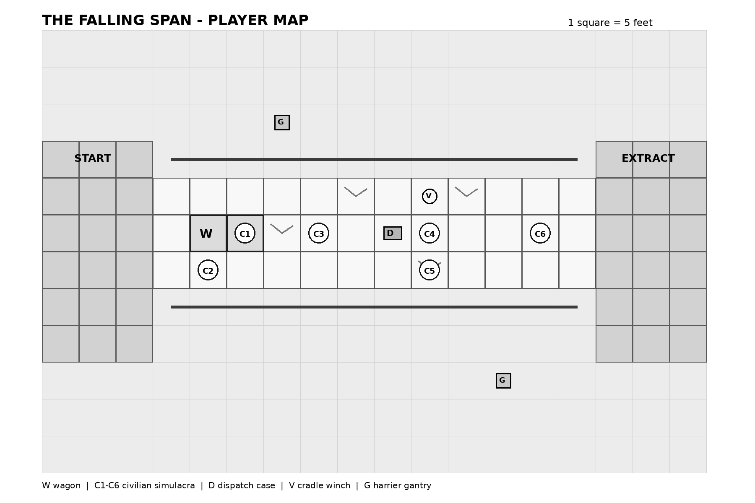
W = wagon | C1-C6 = civilian simulacra | D = dispatch case | V = cradle winch | G = harrier gantry | 1 square = 5 feet

DM Map: Collapse Zones
The DM map adds the scheduled round-4, round-6, and round-7 deck failures. Keep this map behind the screen or on a DM-only VTT layer.
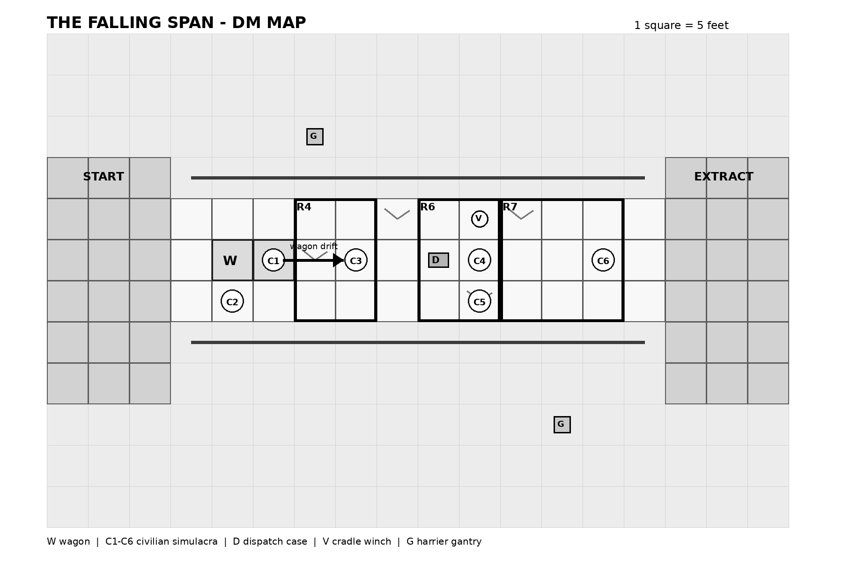
R4 / R6 / R7 = zones removed at initiative 20 of that round. The wagon drifts east beginning round 2 until braked.

